**COMPLETE VPC SETUP**

Go to VPC Dashboard and create VPC

* Name tag
* IPv4 CIDR

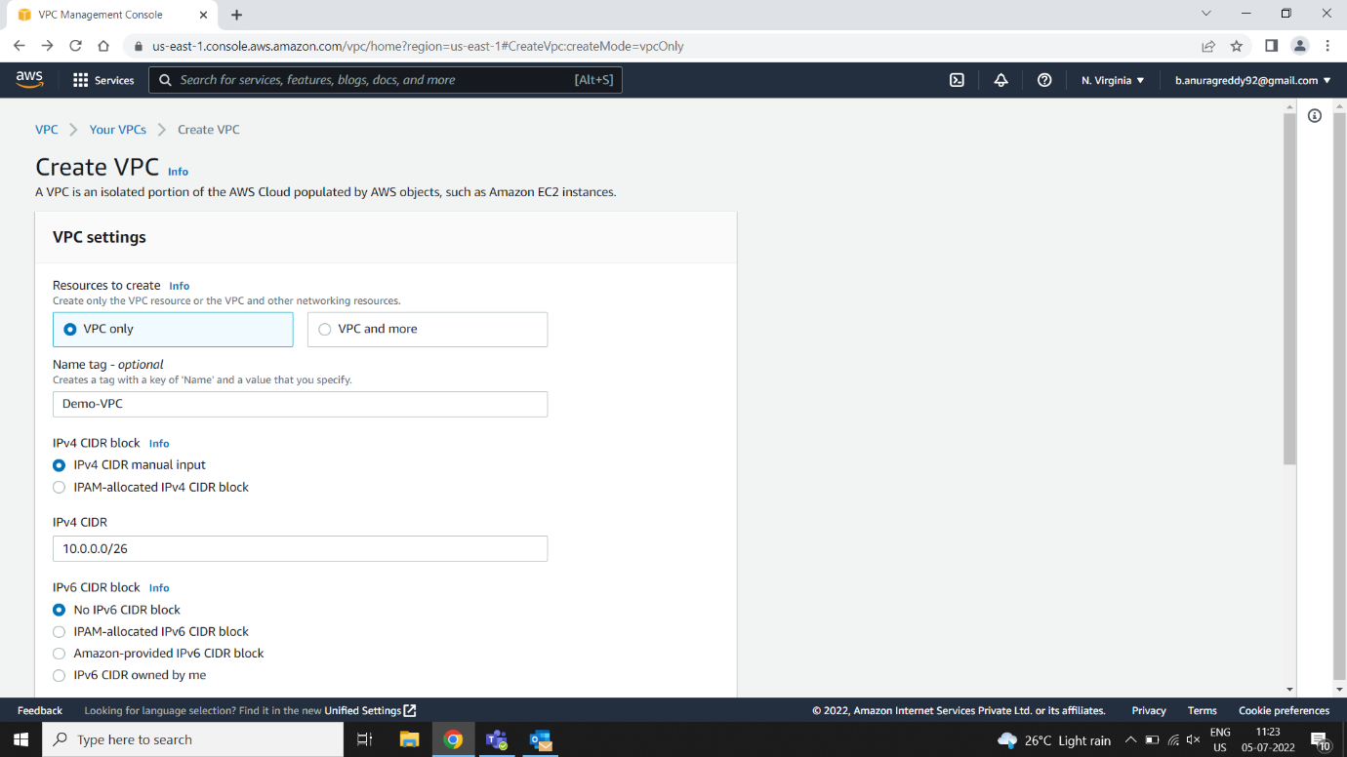

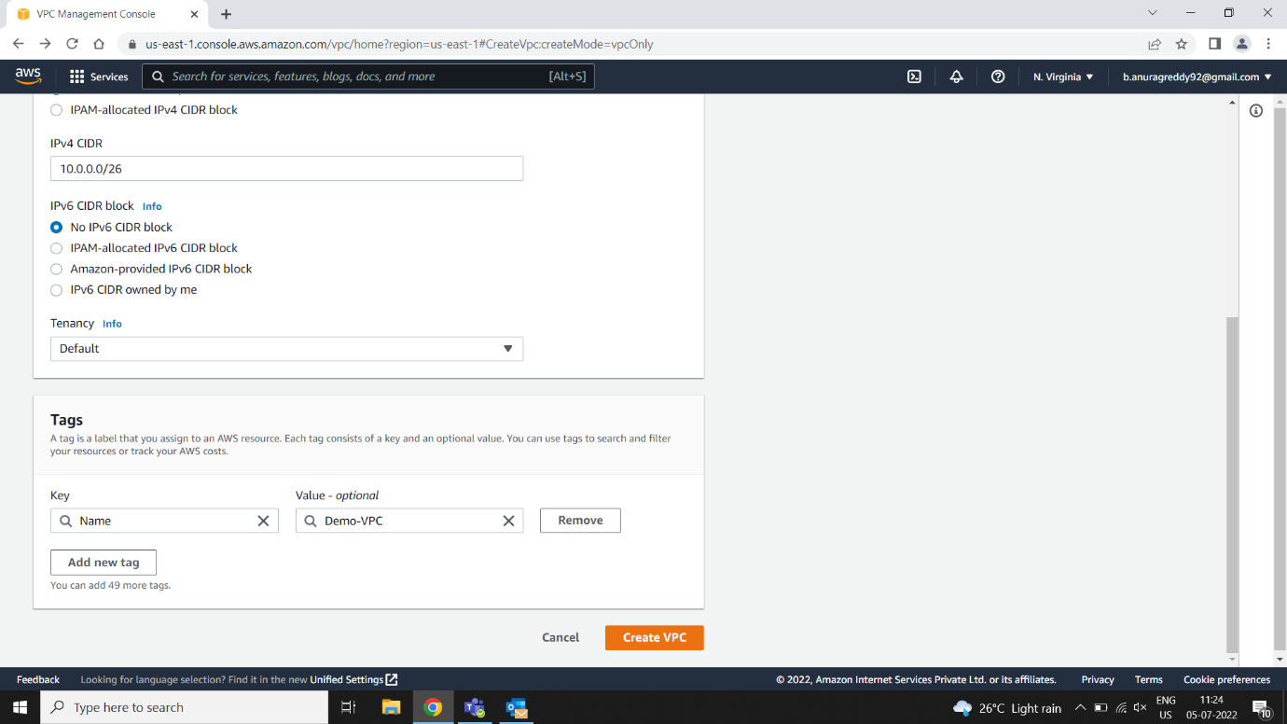

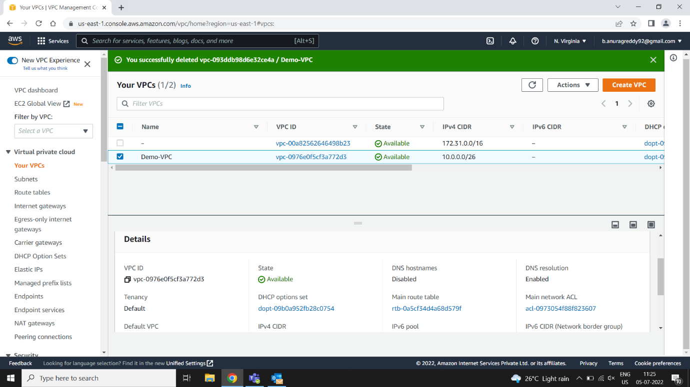

**Next Create Internet Gateway**

* Name tag

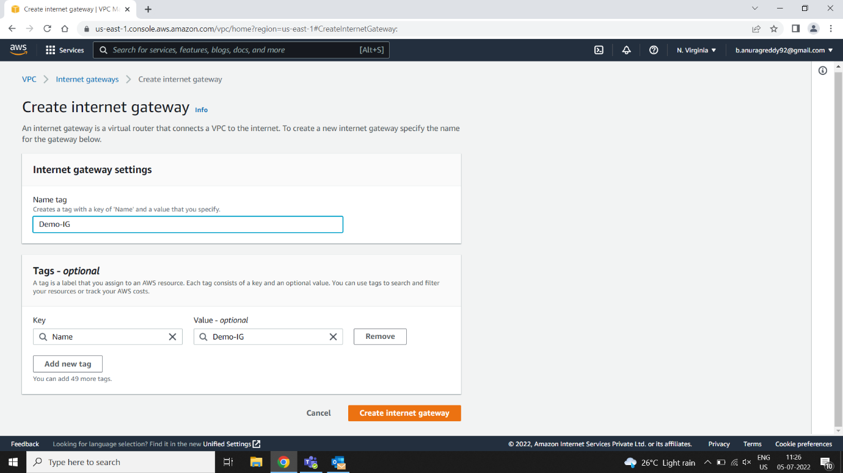

**Attach VPC**

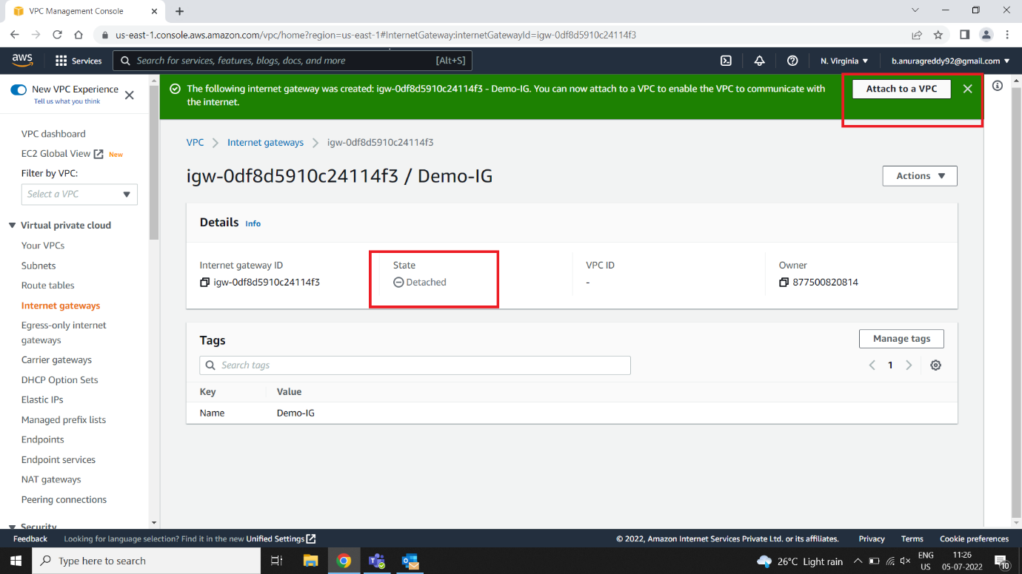

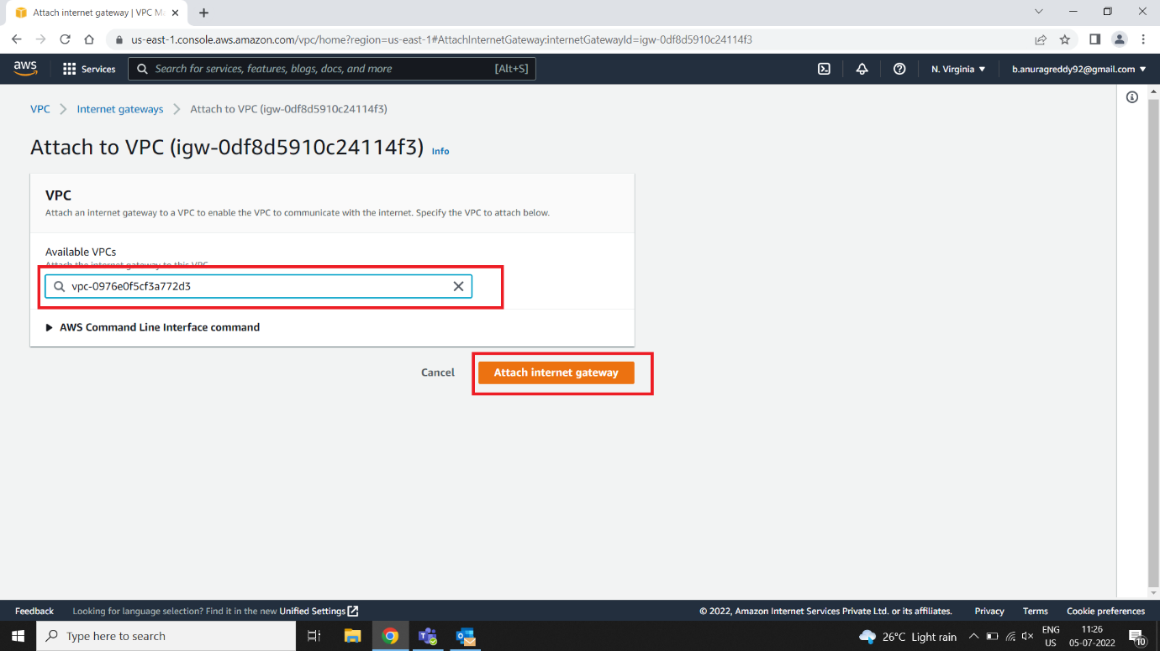

**Create Subnet**

* **Public Subnet**

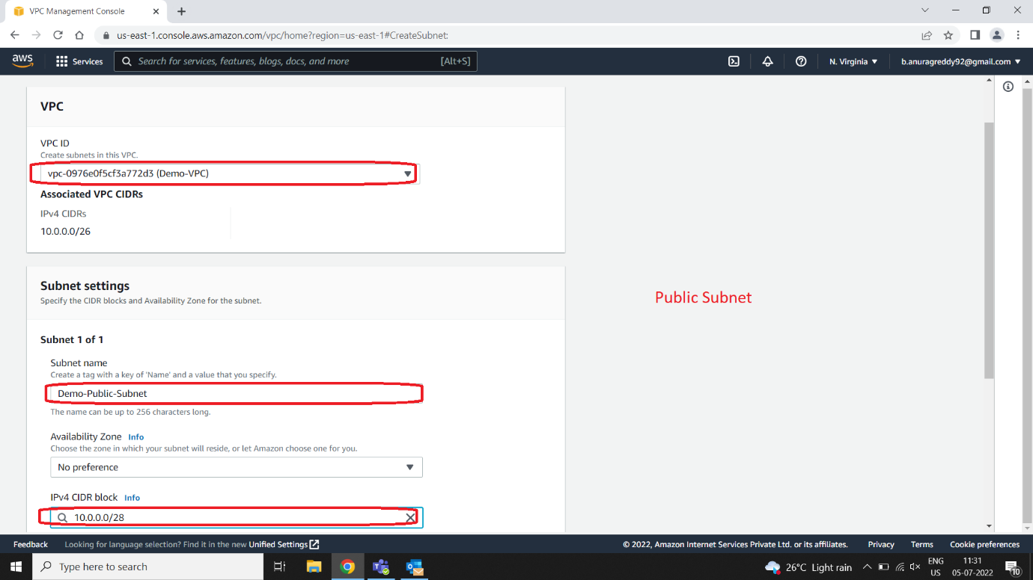

* **Private Subnet**

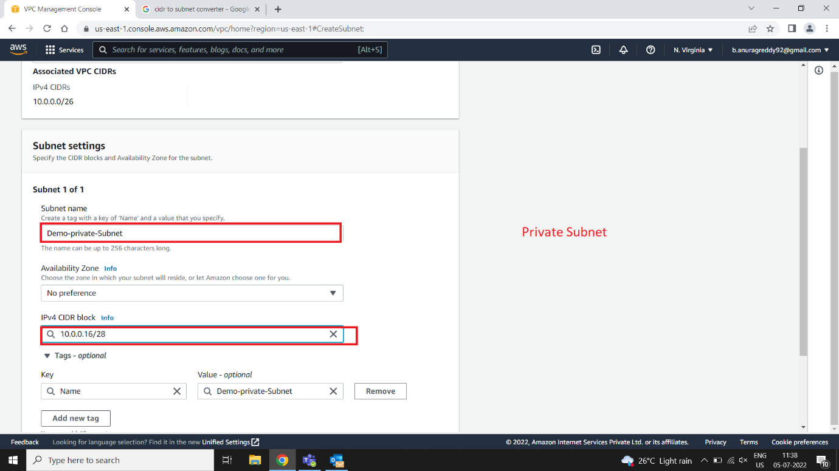

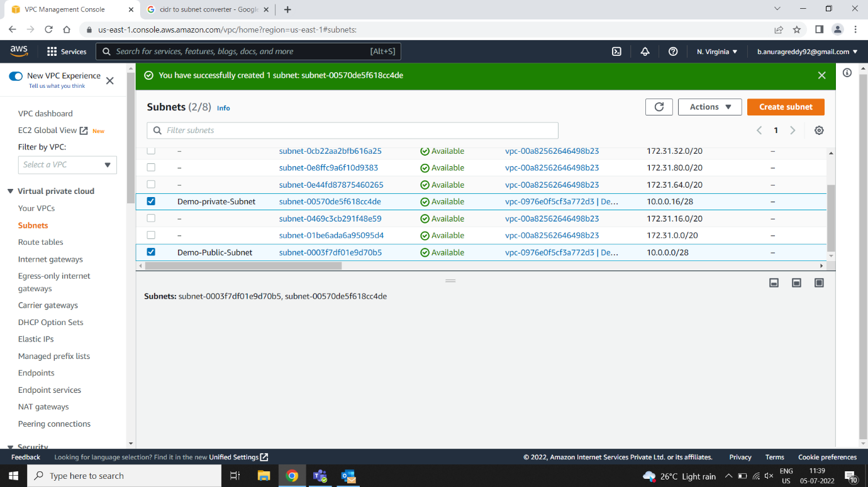

**Create Route Table**

* **Public Route table**
* **Name**
* **Select VPC**

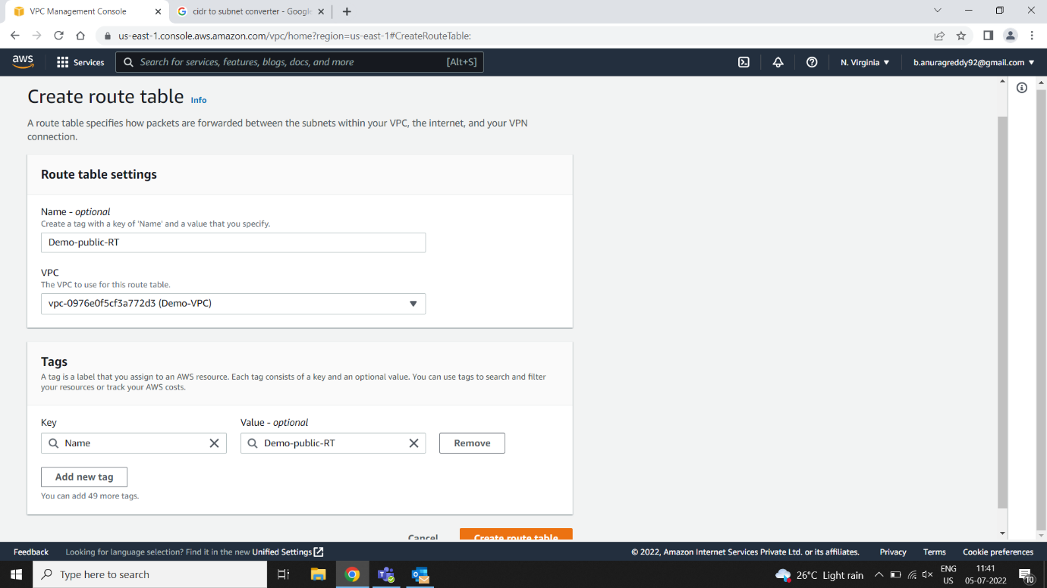

**Create Route Table**

* **Private Route table**
* **Name**
* **Select VPC**

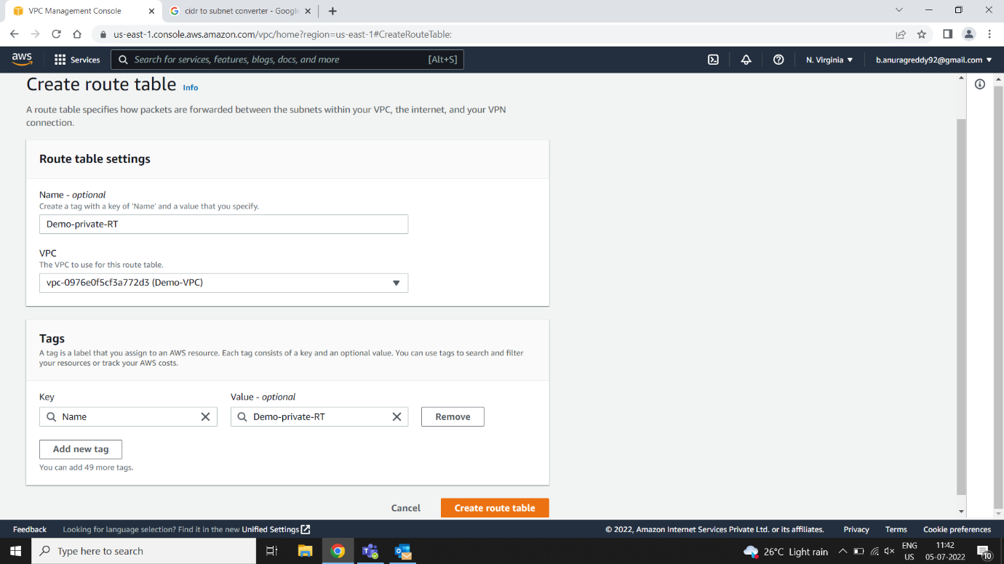

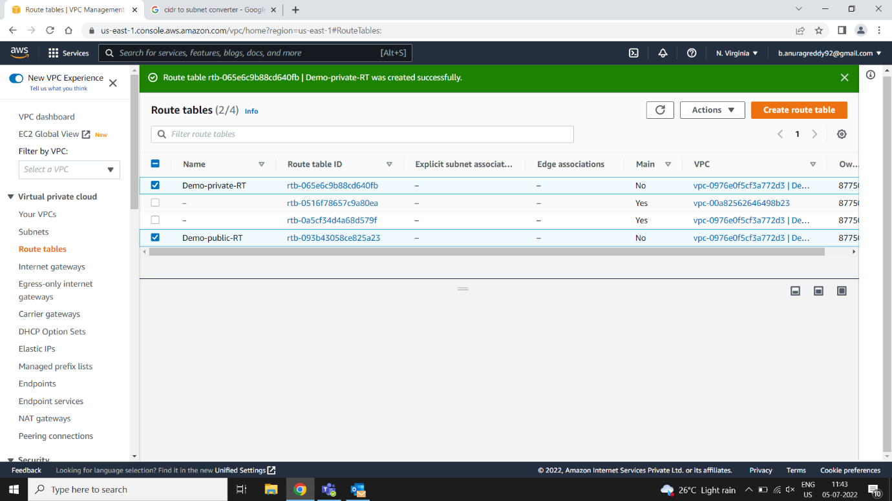

**Edit Subnet Associations**

* **Associations from route table to Subnet**
* **From public_RT to public Subnet and private_RT to private Subnet**

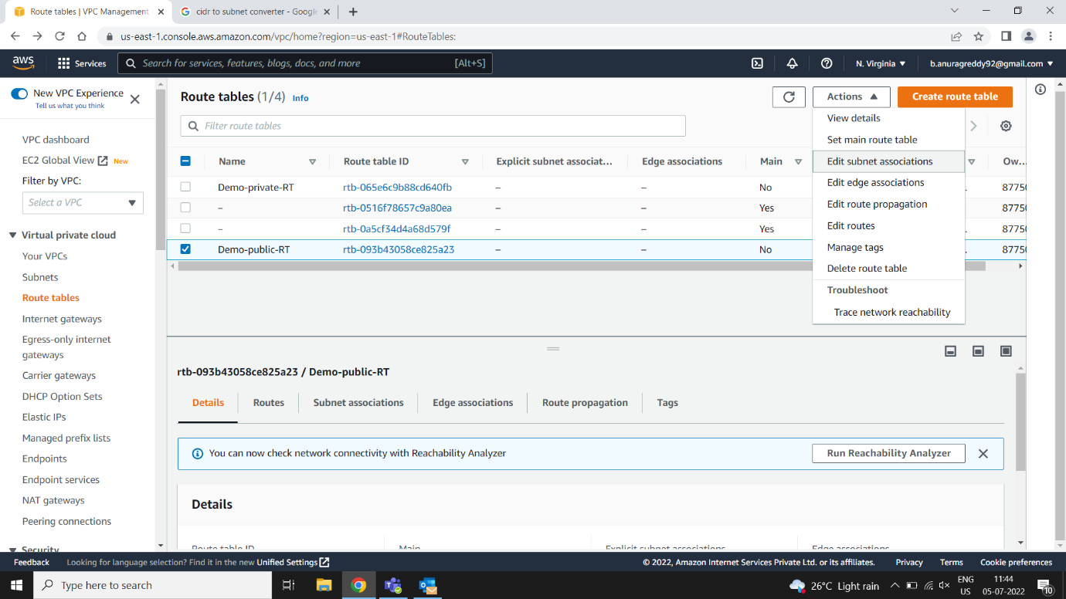

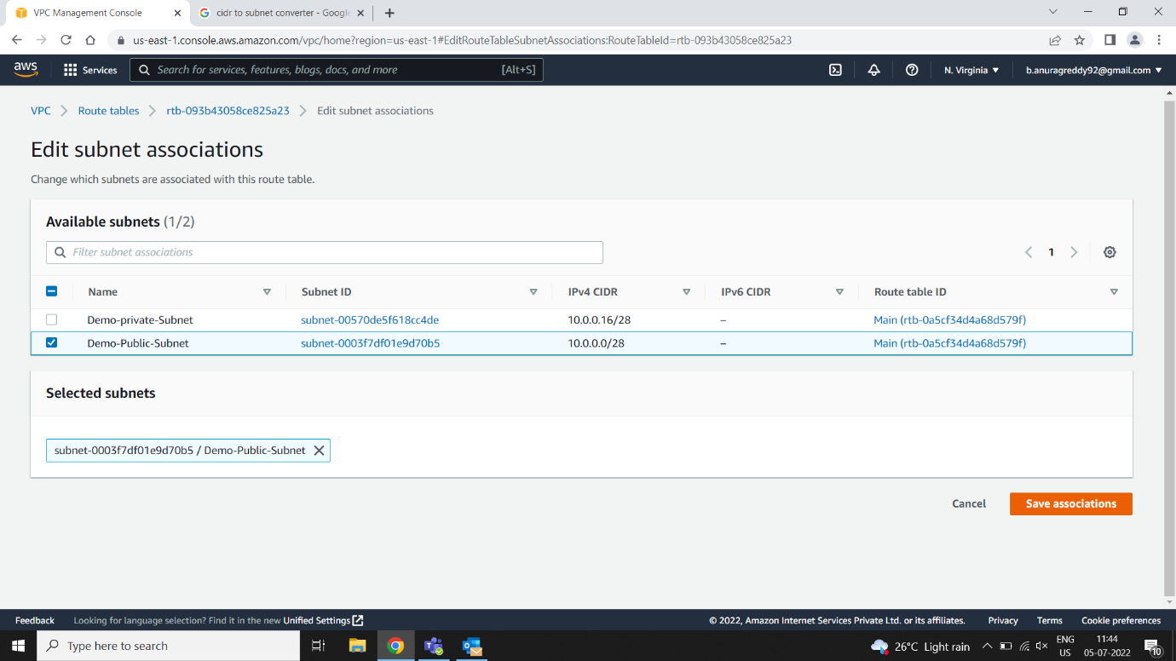

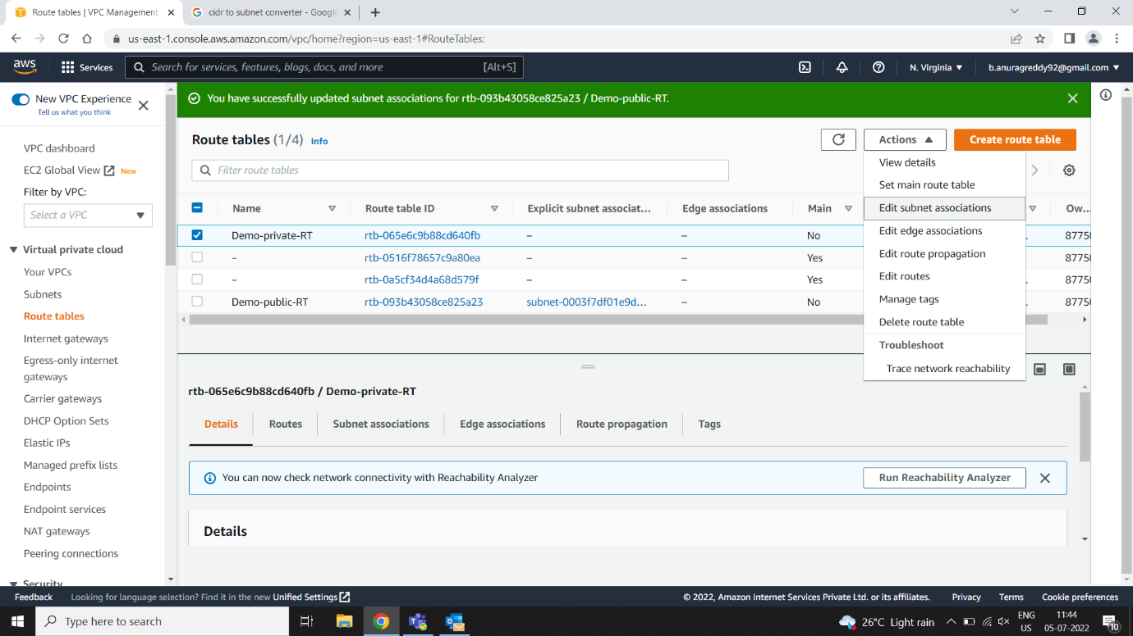

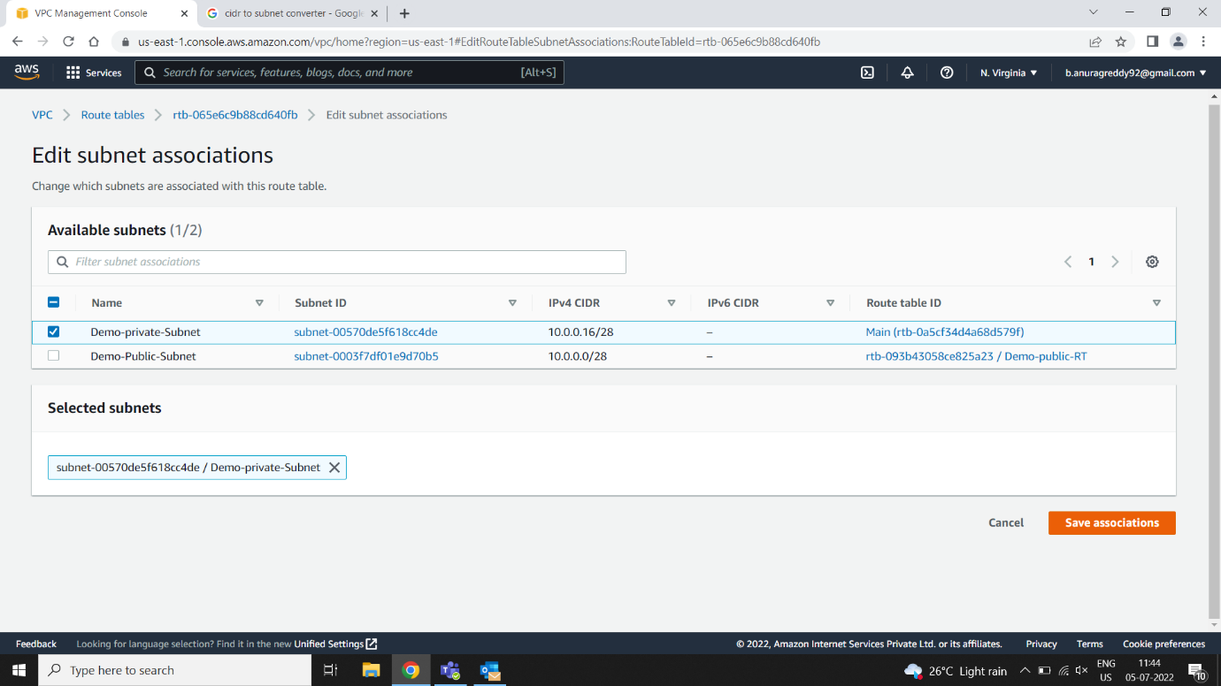

**Action 🡪 Edit Routes 🡪 Add Internet Gateway**

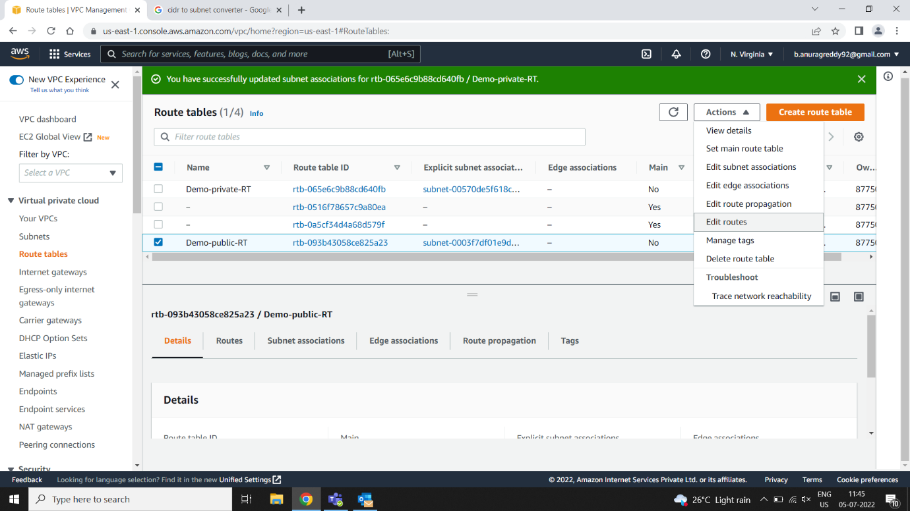

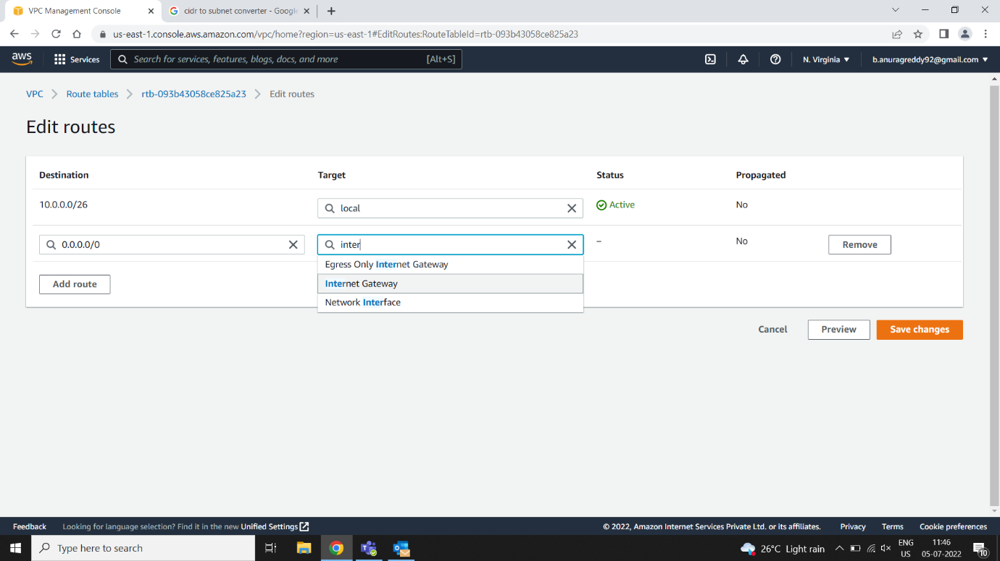

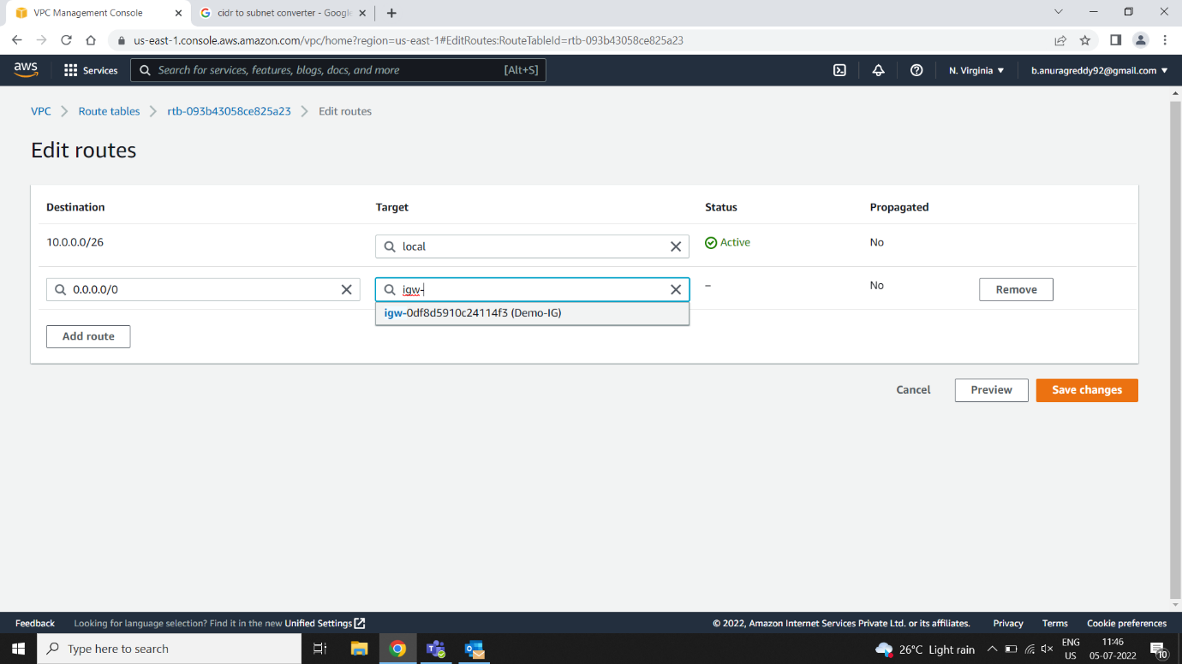

**Creating Public and Private Servers**

* **Public Server**

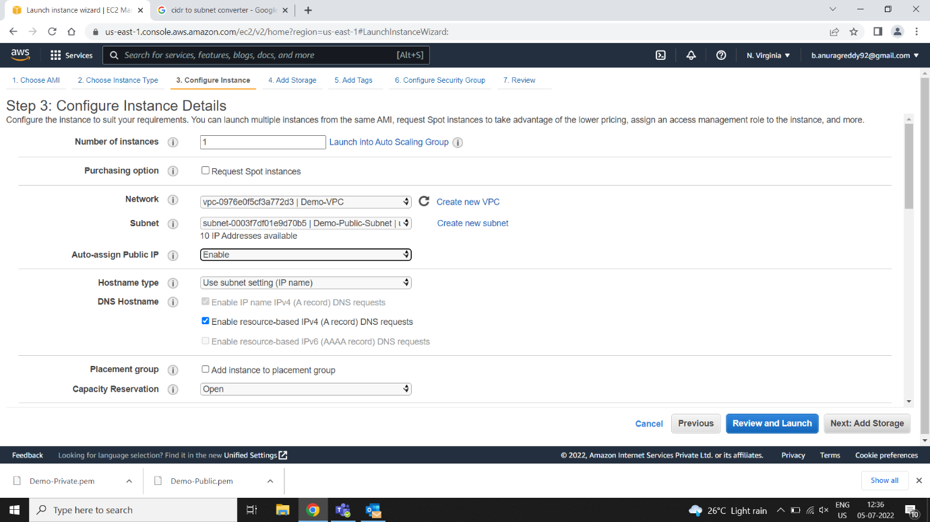

* **Private Server**

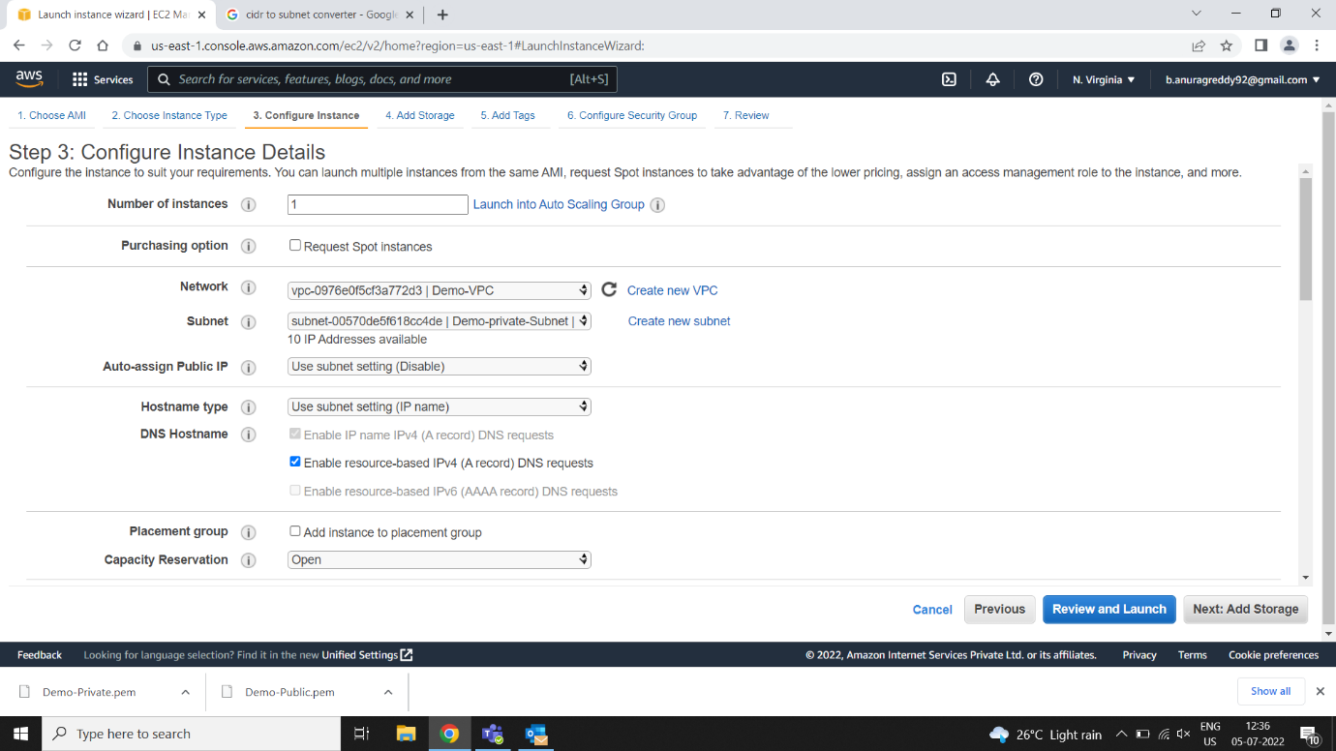

* **Servers created but DNS is not Enabled**

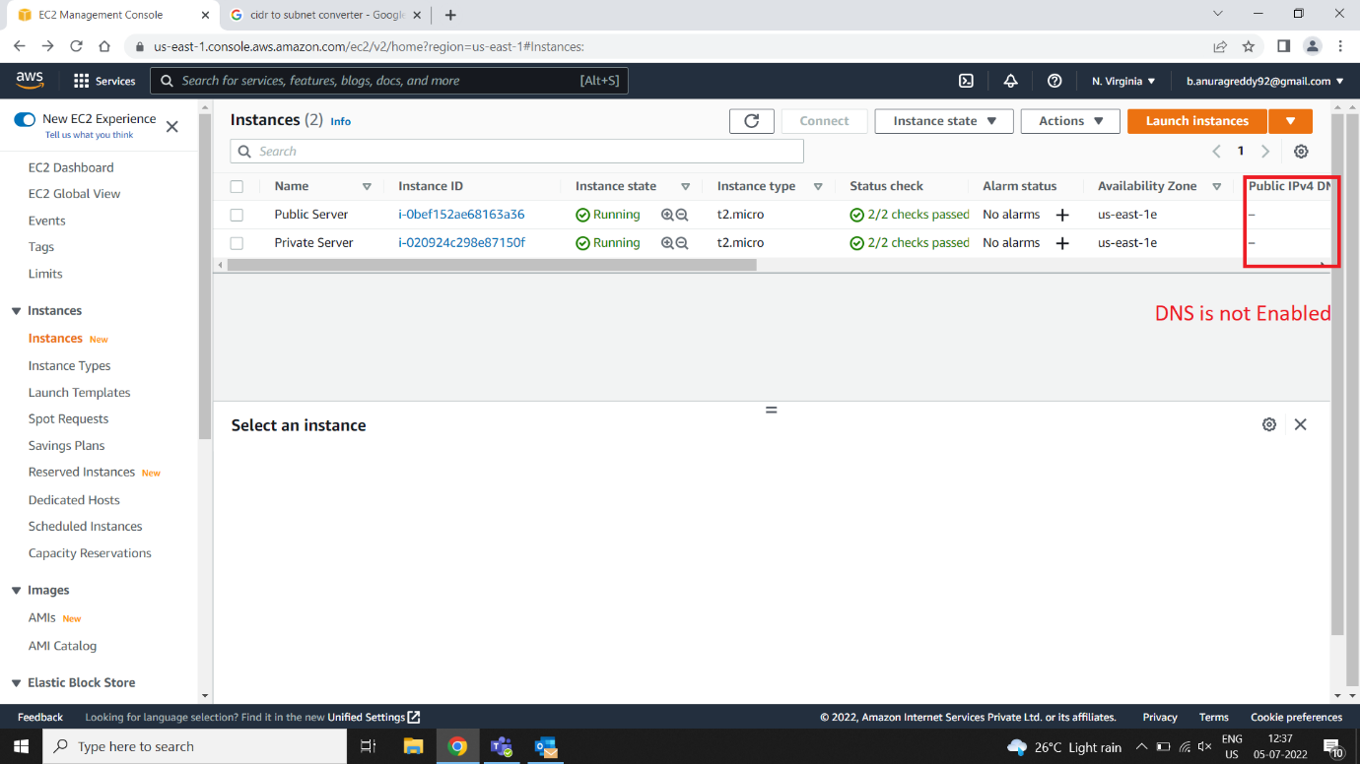

**In Your VPCs 🡪 Actions🡪 Edit DNS hostnames🡪 Enable🡪 save changes**

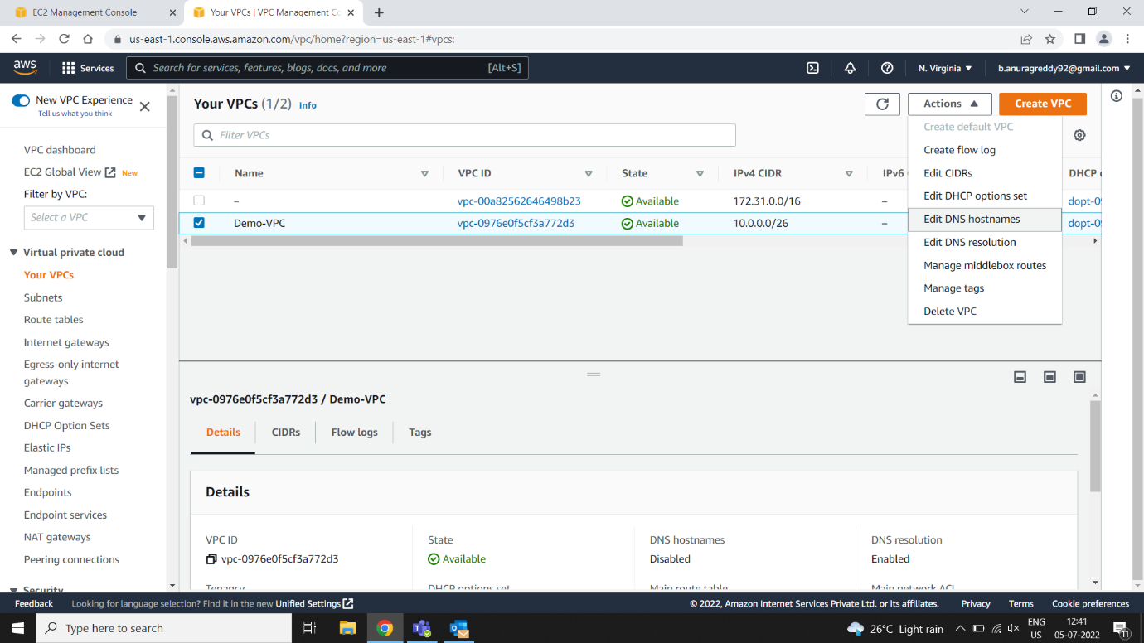

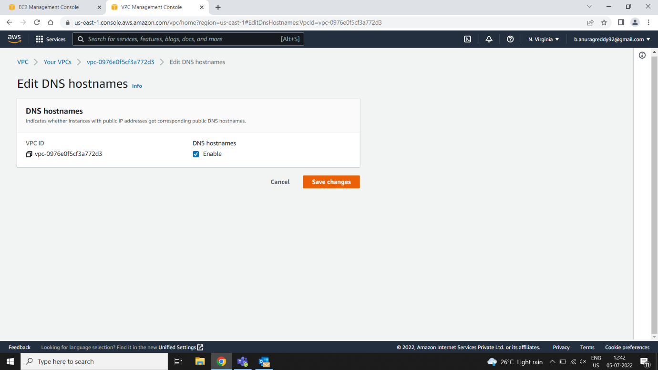

**Now DNS for Public Server is Enabled**

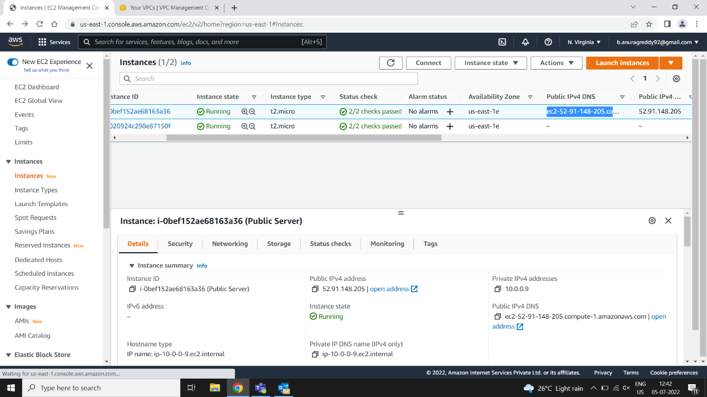

**VPC Setup Completed**